Dalton Murray, Norhan John

Systems Analysis and Design

INT 6123 – Systems Analysis and Design

Dr. Andrew Makar

December 14, 2023

**Case Study 4**

**File Layout (15 points)**

The system needs to send the approved hours to TekSystems as a notification for the billable hours. Using Excel, design the file format to send employee hours, rate and calculated amount for the given week. The Excel file should include the file format and 5 rows of sample data. Refer back to your Case Study 3 class diagram to ensure the contractor id and related contractor information is submitted on the file.

Assume when the data file is sent, it will be in a commas separated file.

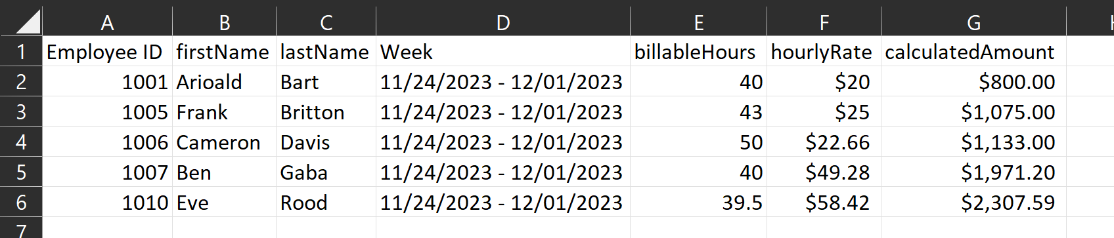

CSV: Attached separately

**Project Estimate and Gantt Chart (15 points)**

Based on your knowledge, develop a work break down structure with duration estimates

In creation of our Gantt chart and schedule we assume we have 4 developers. We will split this into two teams, each team has 2 members. The first team is our front-end team, and the second team is our back-end team. We also assume in this schedule we have everything such as the scope, etc. defined and it is purely based upon the development of the employee portal + timeclock, mass approval/rejection, reporting and invoicing system.

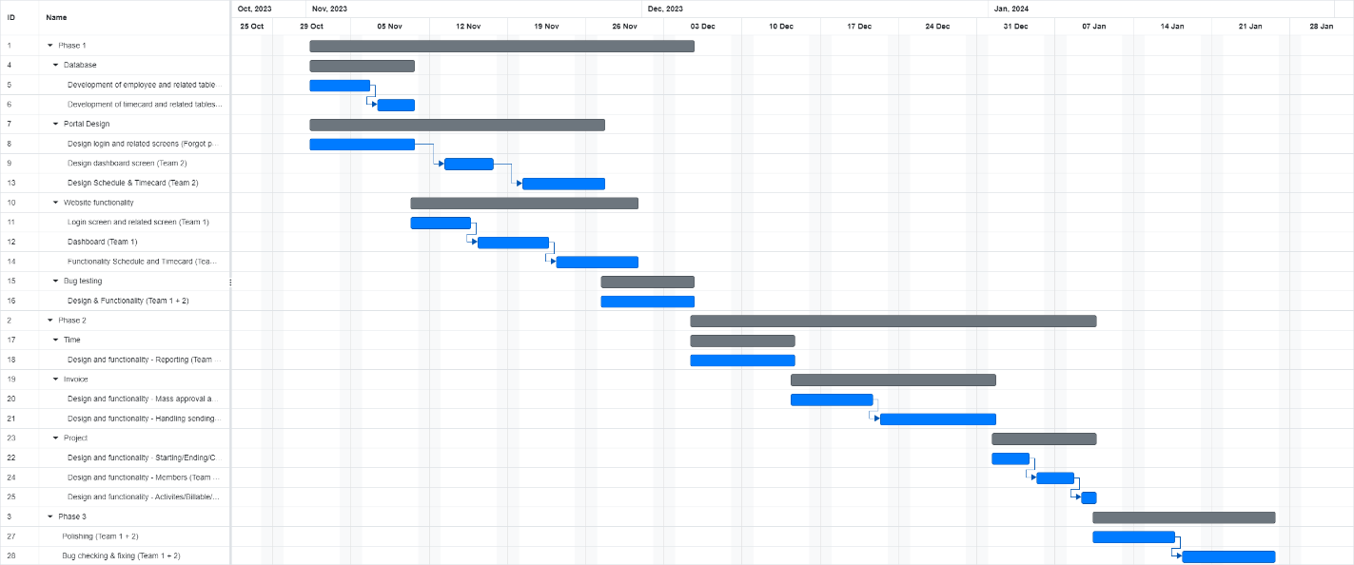

.GANTT, .PDF, .XLSV: Attached separately.

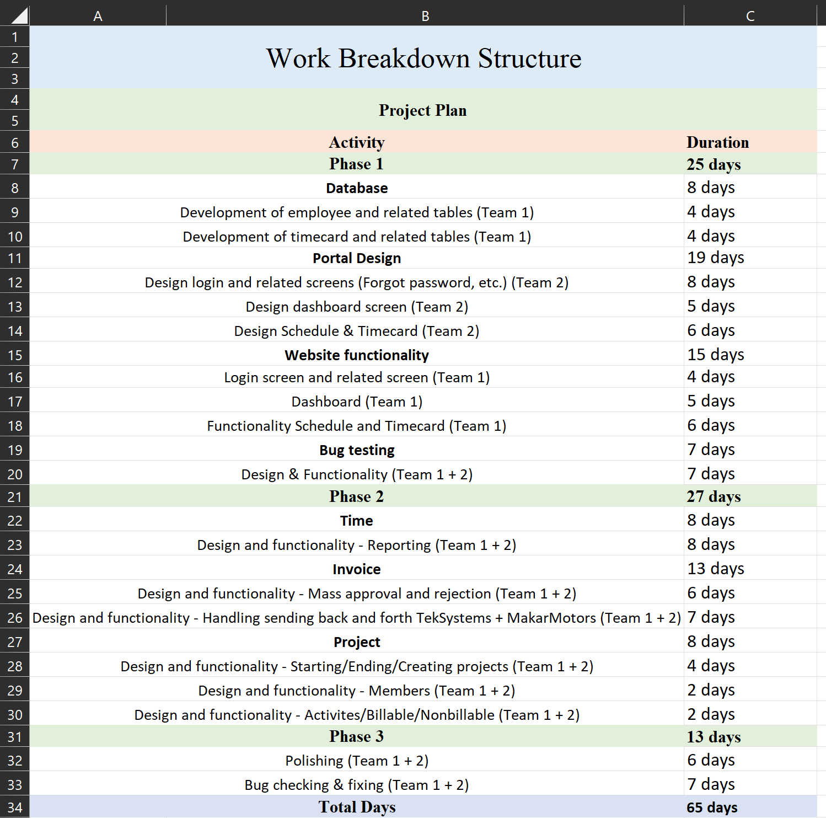

Excel: Attached separately

**Project Deployment (10 points)**

Review the 3 types of deployment options in Chp 14 and determine a deployment method.

Justify your decision on why your selected deployment method is the best option by comparing the method to the other options.

Out of the three deployment options mentioned in chapter 14, direct deployment, parallel deployment, and phased deployment we have chosen the phased deployment method with parallel.

The direct deployment method consists of the creation of the new system and then immediately deploying it while then turning off the old systems (Satzinger et al., 2016. p. 464). With this, both systems will operate at the same time momentarily. With parallel deployment, the old system and the new system are both online for a extended period of time, this can last between weeks to months or even longer (Satzinger et al., 2016. p. 464). This is done so that the new system can be properly and thoroughly bug tested and ensured that it is error-free and ready to operate (Satzinger et al., 2016. p. 464). In phased deployment, the system is deployed in a series of steps, also known as phases, each phase adds additional components or functions to the system (Satzinger et al., 2016. p. 466). With each phase the system is thoroughly tested and ensured that it is bug-free (Satzinger et al., 2016. p. 464). Phased deployment can also be combined with parallel deployment, which we have opted to do so.

We have chosen phased deployment for a number of reasons, particularly because it allows us to deploy the system in a more agile way. We allow the old system to exist while phase 1 is deployed, of course, this is also before and during staff training of the new system. We are doing this because we cannot risk having a problem with the new system and no system to go back to. This allows us to only need to worry about the old system while phase 1 is live and will help ensure a fast and efficient move to the new system. We will then deploy phase 2, and in doing so we will take offline the old system, and then phase 3 which is where the new system will be completely finished. The problem with a direct deployment is that if something happens with the new system after being tested in a development environment and released into our production environment and we cannot use it we can fallback onto the old system. We also did not opt for a parallel only deployment because that would put a lot of stress on our development team and we need the new system to be operational as soon as possible, and the core functionality of the new system is in phase 1, while phase 2 contains some elements which could be considered to be a part of core functionality they are things that can be implemented later while the truly necessary parts are in phase 1, the time clock part, which is another reason why we chose a phased deployment while also being part parallel.

**Test Case Inventory (20 points)**

Now that you have designed the front end and back end of the system, develop 10 test cases to ensure the system works correctly. The test cases should include:

* Test Case Title
* Test Case Steps
* Expected Result for each test step

Using the screen mock ups, develop the testing procedure and expected result. Refer to use cases and user stories

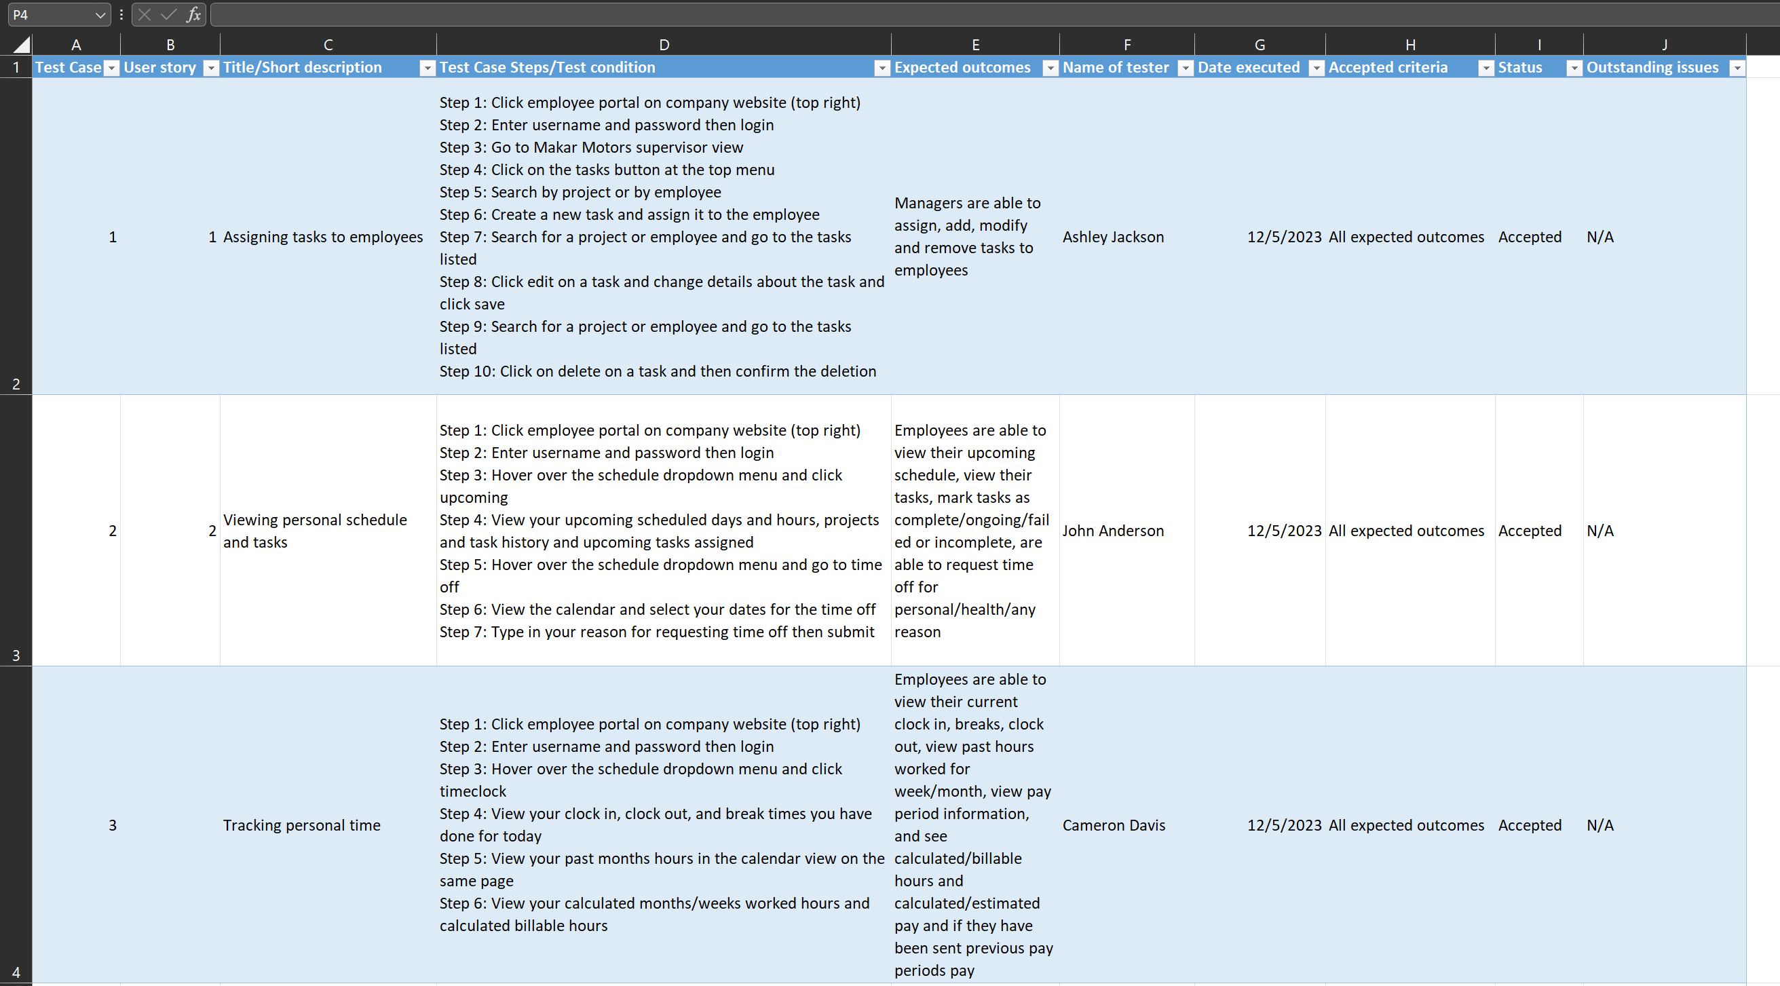

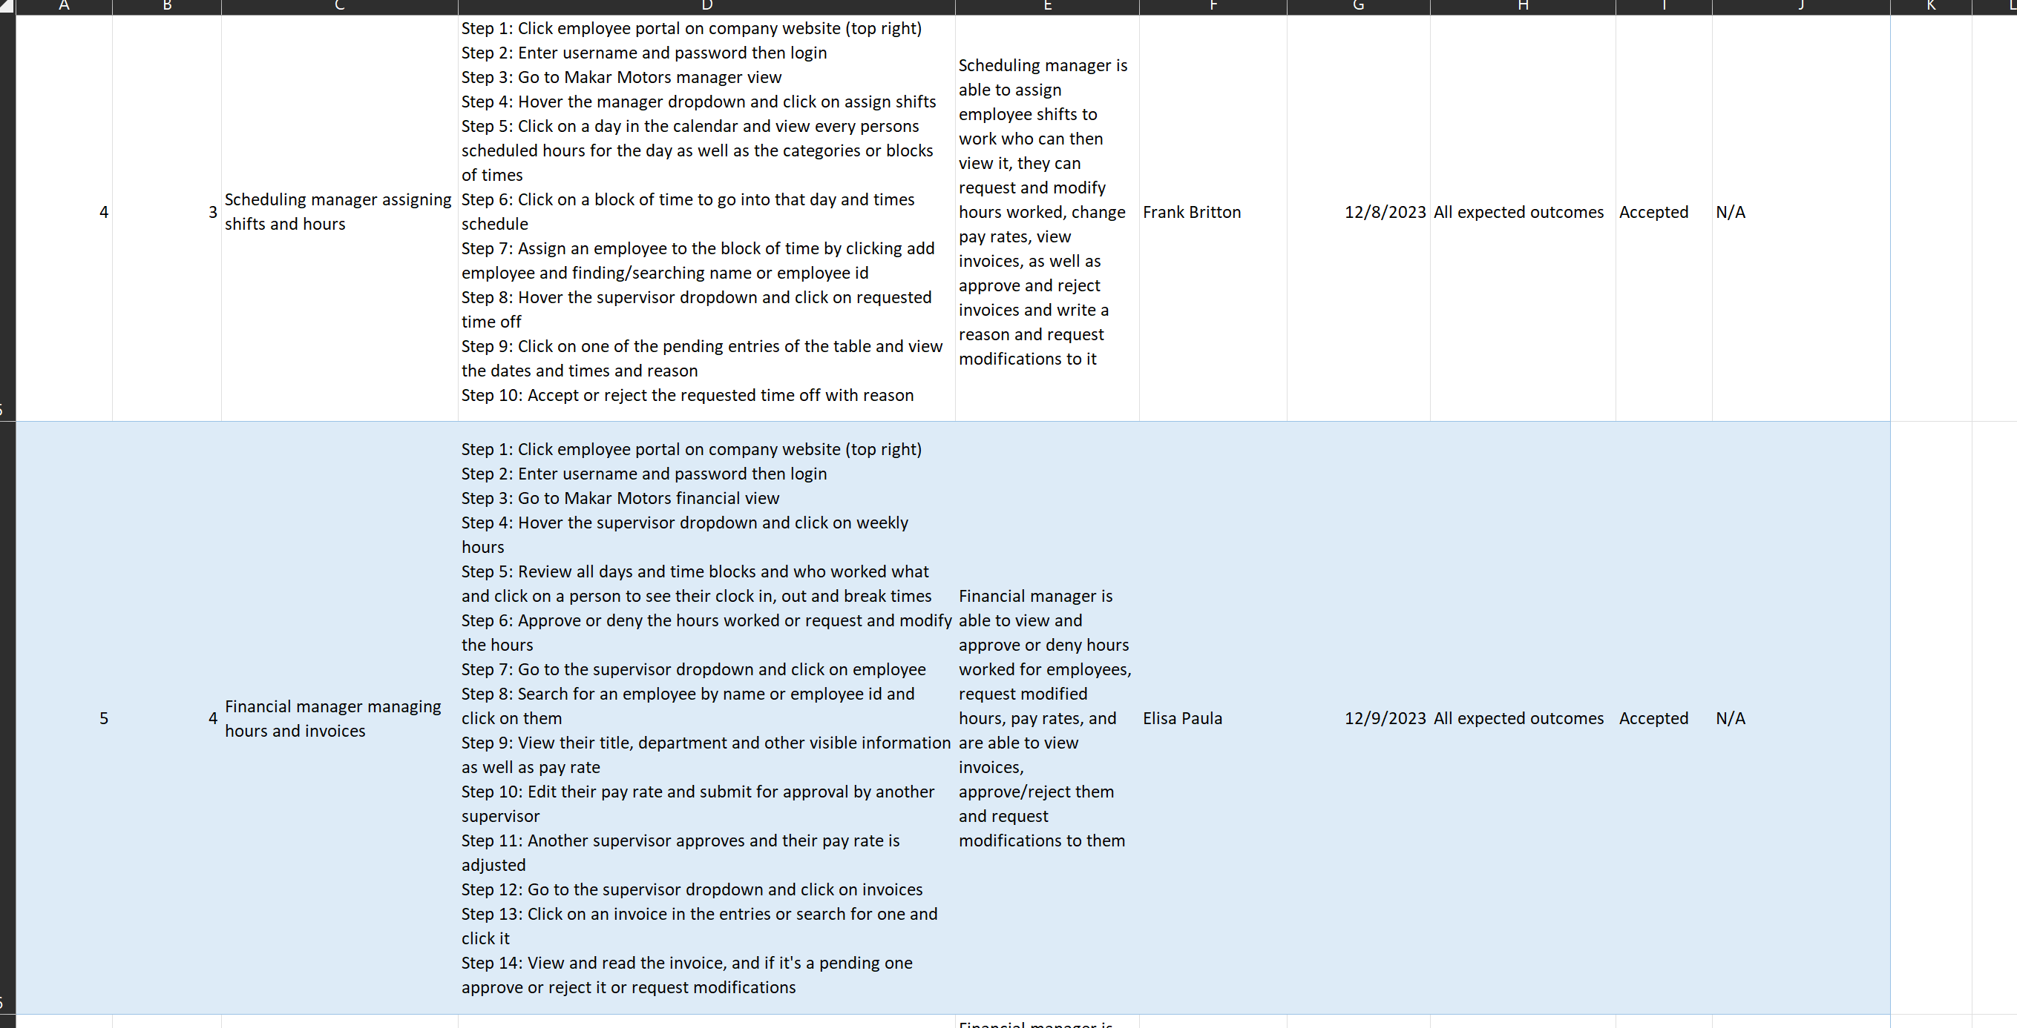

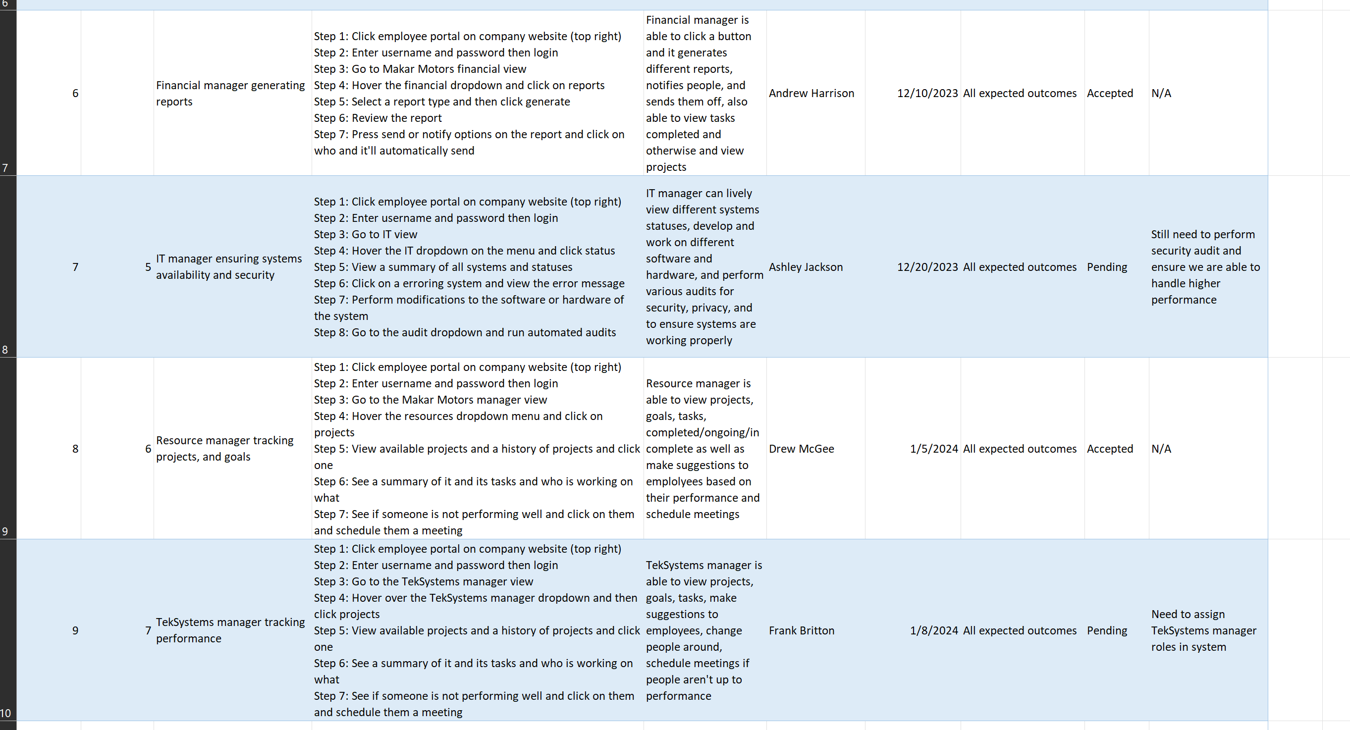

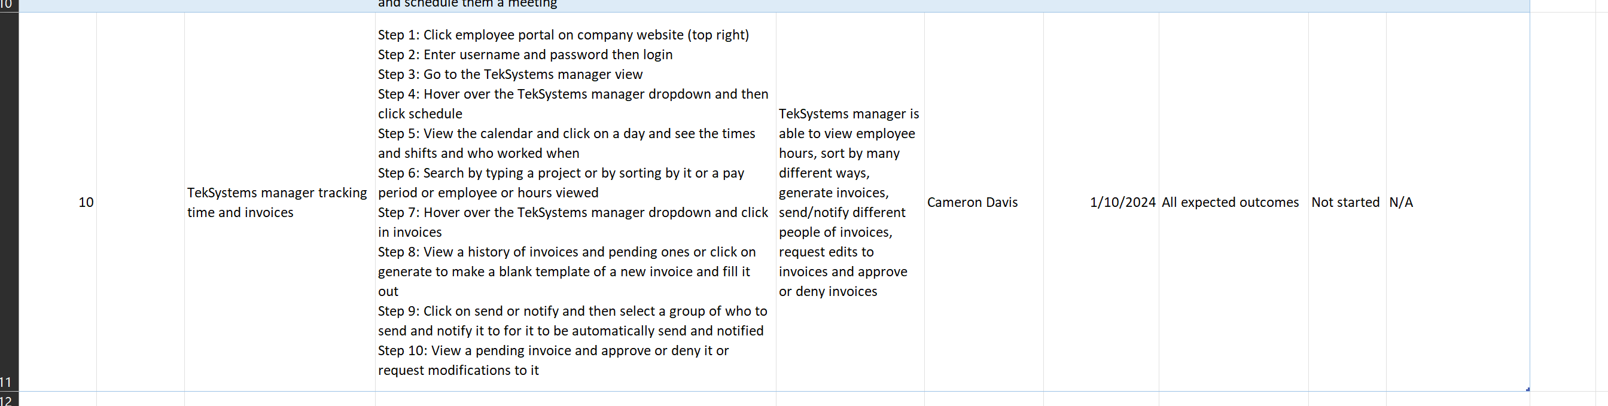

XLSV: Attached separately

**Training Plan (15 points)**

Develop a training plan to roll out the system to managers, employees and Teksystems.

The training plan should address:

* How will the users be trained on the system?
* What is the training model? Classroom, web-based, self-paced, etc
* What is the timeline for the training.

Refer to the text on additional components of the training plan.

**Training Plan**

**Objective**

Our objective is to ensure that each manager, team member, and TekSystem employee learns how to use the new timeclock, scheduling/calendar, and task management systems effectively and efficiently for their respective projects, tasks, and roles. We also want to make sure that they not only learn how to use the system but make suggestions to how we can improve upon the system to make it more efficient so that they can perform the tasks they need in a timely manner, this will also help us make the system error-free.

**Training Model** **& How we will train them**

The training model will be a combination of [60%] web-based (Zoom), [30%] classroom sessions (in-person training), and [20%] self-paced learning (on their own time). The employee will also have a mentor throughout the training period to ensure that everyone is getting the proper training and gaining knowledge, experience, and skills. Each Trainee will be given a checklist to make sure that they are comfortable and knowledgeable of using the system.

During the web-based training, which is where the majority of the training will take place, we will share our screens and use real life scenarios by using test accounts within the system. For example, we will show them how to log in, and how to reset their password and the steps they must take in order to do so. We will also show them how to enable and use the different forms of MFA. We will also show them how to clock in, clock out, take breaks, and modify hours on their end where needed if an error comes up. We will then show them how they can request time off, paid leave, etc. After this, we will show them how to create tasks for themselves, assign tasks, and edit tasks as well as mark them as completed/incomplete/unable to do so. We will also show them how different people are able to see different things within the system, such as an employee vs a supervisor vs a manager vs contractor’s at TekSystems. The web-based training is meant to be more of a training session rather than an interaction session, which is where the classroom style in-person training takes place.

During the classroom style in-person training, we will have them use the systems themselves, interacting with each of them to make sure they know how to do everything. We will also take suggestions, and do QA during this time.

The self-paced learning/on their own training they can do at any period of time and it allows them to make sure they know how to use the new systems without having someone watch over them to make sure they’re doing it correctly.

**Timeline**

The training plan will have a duration of three weeks, with the following phases:

*The training plan is also dependent on when we release our phases and will differ from then. During our phase 1 of deployment we will do some training of people while we slowly phase out the old system, during phase 2 we will perform more training on more people with the new functionality and during phase 3 is when the more mass training will take place.

Phase I: Pre-training assessment and orientation (Day 0)

* The employees will take an online assessment to evaluate their preferred training style, and then the actual training will depend on their answers for this.
  + If they choose solely in-person, they will be able to receive a tailored experience for them in-person along with all of the others who choose this
  + If they choose an online system is when our normal training will take place ([60%] web-based (Zoom), [30%] classroom sessions (in-person training), and [20%] self-paced learning (on their own time))

Phase 2: Training (Week 1)

This is dependent on their previous online assessment, we will cover the normal training scenario.

* The employees will watch tutorials that demonstrate the basic system navigation and functions as well as receive direct training from a mentor or person who is already trained to use the system and trained to train others.
* The employees will receive feedback and guidance throughout the entire training period of web-based Zoom and classroom sessions.

Phase 2: Evaluation (Week 2)

* The mentor of the program for the class/section of training will provide individual feedback and meet with everyone to discuss where to go next
* The mentor will also fill out a training checklist and give it to them as part of their feedback.
  + The checklist will be different depending on employee/supervisor/manager/contractor (TekSystems), it currently shows an employee.

Phase 3: Final training and polishing (Week 3)

* The employees will receive a more tailored experience where the mentor noticed they were lacking skills at
* This is where a majority of the self-paced/on their own time training will take place

|  |  |  |  |  |  |  |  |  |  |  |  |  |  |  |  |  |  |  |  |  |  |  |  |  |  |  |  |  |
| --- | --- | --- | --- | --- | --- | --- | --- | --- | --- | --- | --- | --- | --- | --- | --- | --- | --- | --- | --- | --- | --- | --- | --- | --- | --- | --- | --- | --- |
| **Training Checklist**  Employee Name__________ Mentor Name __________  Employee ID_____________ Training session_________   |  |  |  |  | | --- | --- | --- | --- | | Task | Training Status | Evaluator Decision | Additional Comments | | Employee knows how to clock in/out for their shift and break. | * Complete * Incomplete | * Success * Needs improvement |  | | Employee knows how to mark their task as complete/ incomplete/fail/ success and add any comments. | * Complete * Incomplete | * Success * Needs improvement |  | | Employee knows how to use the system to request day(s) off, put in vacation, call off, and post their shift on the trade board. | * Complete * Incomplete | * Success * Needs improvement |  | | Employee knows and uses at minimum 2FA | * Yes * No | * Is using 2FA * Understands how 2FA works |  | | Employee knows how to reset password | * Yes * No | * Is able to demonstrate resetting a password |  | | Employee knows how to view their pay | * Yes * No | * Is able to demonstrate viewing their pay |  |   Employee Signature____________ Date of feedback____________  Mentor/Evaluator Signature________ |

**References**

Satzinger, J. W., Jackson, R. B., & Burd, S. D. (2016). Systems analysis and design in a Changing World (7e ed.). Cengage Learning.

I have neither given nor received unauthorized aid in completing this work, nor have I presented someone else's work as my own.

*Dalton Murray, Norhan John*